SAVE THE DATE!!!
The Paper Chase Quilting Retreat
Judy Neimeyer Paper Piecing – Pick A Pattern
At Carol Joy Holling Swanson Retreat Center near Ashland, NE with two Certified Instructors Eileen Urbanek and Connie Lange
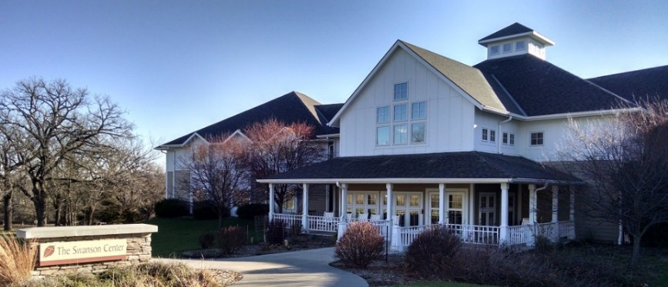
March 9th, 10th, 11th, & 12th - 2017
This will be 3½ day fun filled weekend of quilting, games, prizes, demo’s, trunk shows, and fellowship. The retreat will begin Thursday afternoon with check in from 3:30 to 5:00pm. Welcome at 5:00pm, supper at 6:00pm, and will end on Sunday at 4:00pm. It will include class fee, lodging, 9 meals from Thursday evening to Sunday noon, PLUS a Snack Room with all kinds of beverages, oatmeal, yogurt, snacks, and much more.
Eileen Urbanek and Connie Lange are so excited to have you join them.
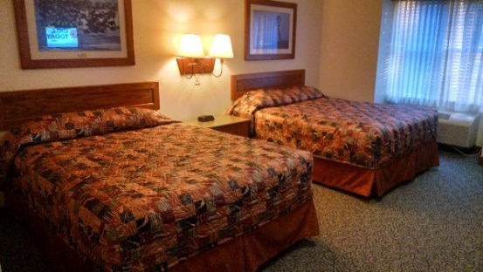

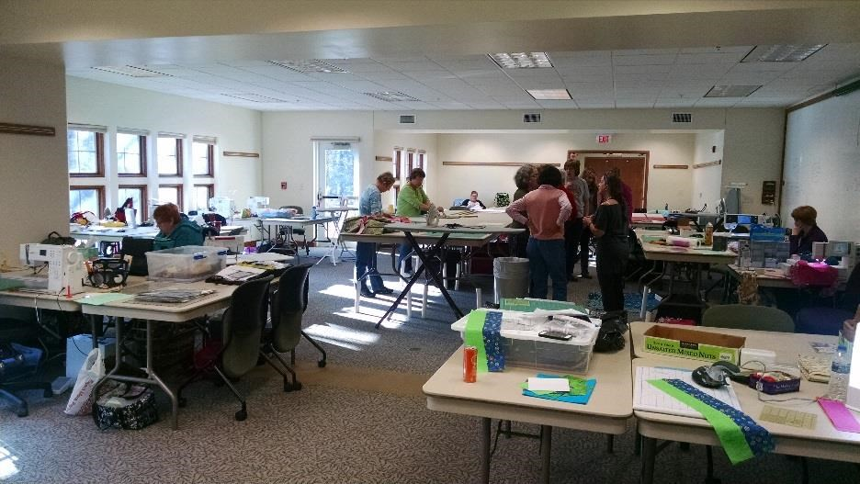
This will be a Pick-A-Pattern retreat, so you will be able to choose any of the Quiltworx patterns that you want to work with. We will have a list of Beginner, Intermediate, and Advanced patterns for you to choose from according to your skill level.
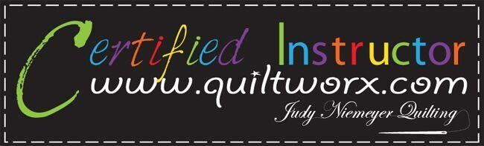
Eileen Urbanek, (www.quiltworx.com/instructors/eileen-urbanek/) will be gracing us with a wonderful Trunk Show in which she will share her journey through her years of quilting. What a fantastic TREAT for us! Connie Lange, (www.quiltworx.com/instructors/connie-lange/) will be sharing her Judy Neimeyer quilts with us.
Don’t miss this GREAT OPPORTUNITY to spend the weekend with two Certified Instructors from Quiltworx. We are going to have so much fun, so start making plans to attend. Eileen and Connie can’t wait to share Judy’s Paper Piecing Techniques with you! See you soon.

For information on “The Paper Chase Quilting Retreat” contact:
Connie Lange – thepaperchaseqr@cableone.net or (402)371-8281

